World War One PBL: Canadian History 11
Michael Wilson
Website
Driving Question: What would daily life be like if was a Canadian soldier fighting on the Western Front during World War One?
Explanation: This PBL will carry over from our in class World War One unit we have been working on three weeks before. This PBL is designed to allow students the ability to delve deeper into the experiences of soldiers in World War One using their own knowledge, research, and interests. The final product is open to interpretation of the groups but I have included examples at the bottom of this document to help students decide on their final product.
Process each day:
-Day 1 Introduction, brainstorm, and learning log: The first class will be focused on reviewing the World War One unit we had completed in the weeks past. I will introduce the driving question and explain that they will create final projects that show they understand daily life of Canadian soldiers fighting in the trenches during World War One. They will have the option to choose their project presentation but all will have to accompany their project with a class presentation showing what they have created. This project will be done in groups of three (I have 27 students). Groups will be made up at random using the Team Shake app.
Once questions have been answered and the project clarified, students will be divided into groups using the Team Shake app. They will then divide into their groups and be asked to begin brainstorming ideas and their focus for the project. They can use brainstorming software like Popplet, SimpleMind, Spiderscribe, etc.… We have used these three before in class so they are familiar with them. They can use their own app or simply write it out on paper if they wish. They will complete the first two sections of a learning log (attached) the third section will be completed when the project is done on day 5.
Once the brainstorm, they should decide how they wish to complete their final project (ex…model, movie, slideshow, photo essay, etc.…). They will tell me which style they choose.
-Day 2 Collaboration and Research: This class will be a research class. Groups should now know their project style and will examine daily life of soldiers during the war. They are to collaborate with each other to determine end goal for the project, resources they wish to use, and sharing knowledge they already know or find during their research. They are reminded to be as creative and unique in their project as possible. Each student has his or her own personality and strengths…. these should show in the final project. Resources to do this research could include:
- For King and Empire documentary series (I have physical copies, can be found on YouTube as well).
- Canadian Archives website in Ottawa. This site contains attestation papers, diaries, regimental photos, and circumstances of death records, battle photos, and regimental histories.
- YouTube to watch the countless documentaries and clips or battle and life during World War One.
- Websites that give good backgrounds to the war.
- World War One books in my personal classroom collection and from the library.
- Class notes from our past lessons on World War One.
Day 3 Compiling findings and creating the project: This project will have them working together in their groups to compile their findings into the project style they have chosen. I will be floating around to make sure questions and concerns are answered and work is being diligently completed so the students meet their deadline.
In the last 20 minutes of class, we will have a talking circle (they have plenty experience doing this in my class) to discuss individual concerns, frustrations with research, final project progression, and overall accomplishments. Everyone will have his or her chance to be heard.
Day 4 Final touches and editing before presentations tomorrow: This is the last period before group presentation tomorrow. Groups should be in the final editing and formatting phase. Group checks will give me the idea who needs help getting ready for tomorrow. Group members should iron out their roles during the presentation tomorrow. Final practicing, timings, and run-throughs should be done before final bell.
-Day 5 Presentations and Final Reflections: Today, each class will be able to show the results of their hard work from this week. Each group will take the stage to show their peers what they have learned and experienced throughout the course of this project. When presentations are done, students will be asked to finish their learning logs to wrap up the project (see the learning log attached). This may need to run into another day if needed.
How will progress be monitored? Daily checks/monitoring, talking circles (we will meet mid week to discuss problems/roadblocks/achievements as a group…we have done this before on other projects). We will also have progress check-ins with me.
Technology used: MacBook, desktop computers, tablets (most have access to I Pads. Some have own.), overhead projectors, presentation software (PowerPoint, Keynote, I-Movie), presentation apps (school I Pads have some…. personal devices have a wide variety), For King and Empire documentary series, YouTube, websites, etc.…
Final Product: All projects must have a presentation showing what they have learned about life in the trenches during World War One. They will have the ability to choose this project type and will have to present it to the class. Example choices for the final displays can be:
- A model of the battlefield. This model must show factors such as: trench systems, No Man’s Land, machine guns, field artillery, barbed wire, and chemical gas.
- A PowerPoint or Keynote showing images and short explanations or daily life in the trenches (risks, conditions, daily structure, food, technology, expectations).
- A photo essay (assignment attached) showing the following: (Photos with one paragraph explaining each photo. Example photos could include:
- Soldiers signing up for the war. (Recruiting centers, attestation papers being signed, propaganda etc.…)
- Soldiers training for the conflict.
- Soldiers saying goodbye to loved ones.
- The trip overseas (cargo ships, troop trains, etc.….).
- The condition of the trenches. (what did they look like? Duckboards, rats, trench foot, gas attacks, water and mud, etc.…)
- New technologies (machine gun, submarine, repeater rifles, chemical gas, zeppelins, fighter and bomber planes, tanks, creeping barrages, etc.…
- Soldiers camaraderie and bonds with each other (hanging out behind the lines, playing games, relaxing, the bond of soldiers willing to die for each other, etc.…
- Images of battle (show the emotion (fear, helplessness, anger, despair, etc.….) of combat.
- The after effects of war (scarred battlefields, trench graves, grave sites, wounded or shell-shocked soldiers, etc.…)
- Returning home (the embrace of loved ones, disembarking from ships or trains, celebrations, etc.…).
- A 2 minute movie showing similar images as the photo-essay. This must be set to music and have the following:
- Transitions
- Text that goes along with your song.
- Quotes
- Must show daily life for everyday soldiers.
- Must capture the audience and evoke emotion from them.
- Must flow with a clear beginning, middle, and end.

**** These are just examples. I would encourage students to make their project format unique to them. The above examples are to get them thinking of possibilities for their final project.

Time: 5 classes (total 5 hours)
Outcomes: GL4 : Analyze the role played by WWI in shaping Canada's identity.
SCO1: Identify and describe continuing/persistent questions that have deep roots in Canada's history.
SCO2:Identify those individuals, events, and/or symbols that they believe have contributed to the development of Canada and explain their historical significance.
GL6 Analyze the evolution of Canada's roles in the 21st century.

World War One Project Learning Log

Name:
What I Already Know  (Name as many facts as you can) | What I Want to Know  (At least 5 aspects you don’t already know) | What I Learned…(complete at end of the project).
-Example: Soldiers fought in trenches. | -Example: What did soldiers eat while in the trenches? | -Example: Soldiers would eat cans of bullied beef and tough biscuits called “hard tack”.
This part of your project is worth 10 points. To be turned in with your final project.

Back

World War One Photo Essay Assignment

Canadian History 11
Mr. Wilson
mrwilson@staff.ednet.ns.ca

For this assignment, you will be creating a photo essay for the World War One. Photo essays tell the story of an event using dramatic pictures followed by descriptive text. The text does not need to be long and should be around 1-2 paragraphs below the picture.
Each slide should have 1-3 pictures and a short write-up describing the photo or event shown in the photo…this has to be in your own words.

Below is a list of topics for each slide. Some have more than one choice.
Slide 1: Title slide (title, your name, date submitted, and one picture.
Slide 2: Soldiers signing up for the war. (Recruiting centers, attestation papers being signed, propaganda etc.…
Slide 3:Soldiers training for the conflict.
Slide 4: Soldiers saying goodbye to loved ones.
Slide 5: The trip overseas (cargo ships, troop trains, etc.….).
Slide 6: The condition of the trenches. (what did they look like? Duckboards, rats, trench foot, gas attacks, water and mud, etc.…)
Slide 7: New technologies (machine gun, submarine, repeater rifles, chemical gas, zeppelins, fighter and bomber planes, tanks, creeping barrages, etc.…
Slide 8: Soldiers camaraderie and bonds with each other (hanging out behind the lines, playing games, relaxing, the bond of soldiers willing to die for each other, etc.…
Slide 9: Images of battle (show the emotion (fear, helplessness, anger, despair, etc.….) of combat.
Slide 10: The after effects of war (scarred battlefields, trench graves, grave sites, wounded or shell-shocked soldiers, etc.…)
Slide 11: Returning home (the embrace of loved ones, disembarking from ships or trains, celebrations, etc.…).
Slides 12-16: An important event/battle for each year of the war (1914, 1915, 1916, 1917, 1918)
Slide 17: Sources for your information and images (websites you found your information and pictures….all must be listed).

Things you must have:
- Title slide
- Colour
- Information must be in your own words.
- Picture and information on the same slide and compliment each other.
- All websites and sources cited on last slide.
- Spelling and grammar is accurate
- Make your presentation visually appealing. Back
World War One Movie Project

Canadian History 11
Mr. Wilson
mrwilson@staff.ednet.ns.ca

For this assignment, you are asked to create a two-minute video showing daily life of soldiers in World War One. This video can be done on any program you wish (I-Movie, Media Player, etc.….). Things to consider:

- Your video should evoke the raw emotion of daily life in the trenches. You are telling a story with images.
- You should have a brainstorm or storyboard that shows planning before the video is created.
- You should have flow to your video. A clear introduction, middle, and end will make the viewer follow the story you are trying to tell.
- Add quotes, soldier testimonies, poems, etc.…. with your photos. Text should be timed so viewers have ample time to read what is on the screen.
- You must have music to accompany your film. This music should be timed with the photos. The music will help tell your video story.
- Add transitions to your video. Make it visually appealing.
- Try to tell the whole story of a soldier’s life in the war (the good, the bad, the funny, the sad). Examples: soldiers saying goodbye to loved ones, soldiers playing card or soccer, soldiers under fire, wounded soldiers, soldiers visiting graves of friends, the wounded and the dead, etc.…
- The video should be a minimum of two minutes. It should have a clear ending and leave the viewer pleased with the progression. Tell a story in those two minutes.
- Make your video unique. No two videos should be alike. Put your own personal spin on it.

Due Date: To be announced.

<--Back

World War One Model Project

Canadian History 11
Mr. Wilson
mrwilson@staff.ednet.ns.ca

For this assignment, you are asked to create a sandbox style model of what a World War One battlefield would have looked like. This model will follow the same guideline as we used in our recreation of a traditional Acadian village we did at the beginning of the course. I will provide the same paint we used for the Acadian project. You all used papier-mâché last time so that is an option…. you are free to use any other materials you wish.
You are encouraged to use your creativity to create the model using everyday materials around you each day. Example: The dollar store has plenty of cheap toy soldiers that can be painted, twigs could be glued and panted to make machine guns, snapped tree branches could be shattered trees, popsicle sticks could be trench reinforcements, thin metal wire could be barbed wire defenses.
Components you should consider:
- Show key factors of a World War One battlefield (trenches, No Mans Land, shell craters, machine gun emplacements, soldiers in the tranches and in No Mans Land, flamethrowers, etc.…).
- With each component, attach a brief description on the model that describes what the component is and how it affected soldiers (small strips of paper are ok).
- Paint your model. Research what colour certain elements where (tanks, planes, uniforms, etc.…)
- Your final model should give the viewer a birds-eye view of what a World War One battlefield would look like. Make it look as realistic as possible.
- Be creative. Show how you can alter everyday items into model pieces.

Example:
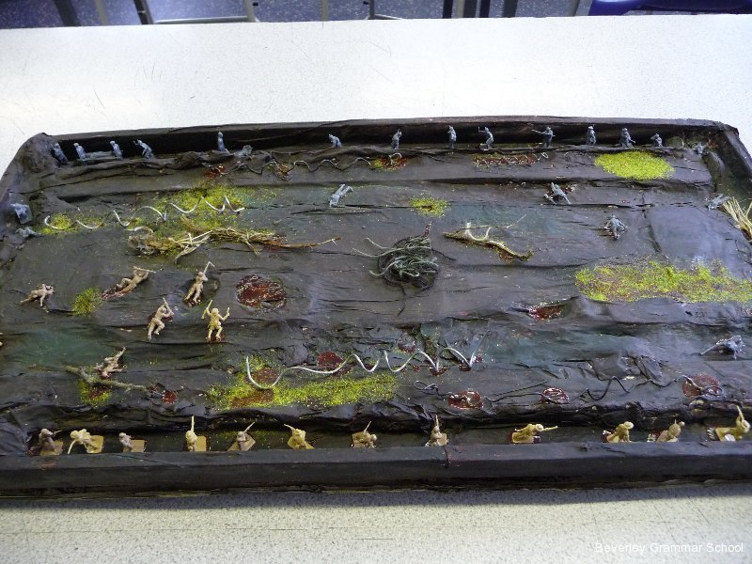
Back
World War Slideshow Project

Canadian History 11
Mr. Wilson
mrwilson@staff.ednet.ns.ca

For this assignment, you are asked to create a slideshow showing and explaining what World War One was like for the everyday soldier fighting in this monumental conflict.
You will use presentation software of your choice (PowerPoint, Keynote, etc..) to create a presentation using a blend of images and information to tell the story of these soldiers.
Possible things to include:
- New technologies (machine guns, submarines, tanks, airplanes, chemical gas, gas masks, zeppelins, flame throwers, etc.…).
- Key Canadian battles (Vimy Ridge, Kitchener’s Wood, Passchendaele, the Somme, Vierrers Ridge, Beaumont Hamel, Flanders, etc.).
- Risks in the trenches (gas, trench foot, shrapnel, snipers, bomber planes, artillery, rats, etc.).
- Environment (no mans land, trenches, bunkers, pillboxes, barbed wire entanglements, tunnels, etc.).
- Entertainment (trench games, sports, betting games (common with fighter plane duels), card games, plays, etc.).
- Famous Canadians (John McCrae, Billy Bishop, Womp May, Egar Adamson, Leo Clark, Sam Steele, Talbot Papineau, etc.…)
- Monuments (Vimy Monument, Beaumont Hamel Newfoundland Memorial, Windmill 42nd Memorial, Menin Gate, etc.…).
- Canadian Battalions and Units (85th Nova Scotia Highlanders, 42nd Black Watch, Royal 22nd “Van Doos”, No. 2 Construction Battalion, Royal Canadian Regiment, Princess Patricia’s Canadian Light Infantry, etc.…).

Aspects of the slideshow should have:
- Colour.
- Title Slide with title, name, and date submitted.
- A mixture or text and images.
- Slide transitions and animations.
- Bibliography citing sources or text and images (Chicago Format)
- All slides must have a title.
- Aim for 10-15 slides.

Due Date: To be announced

Back

